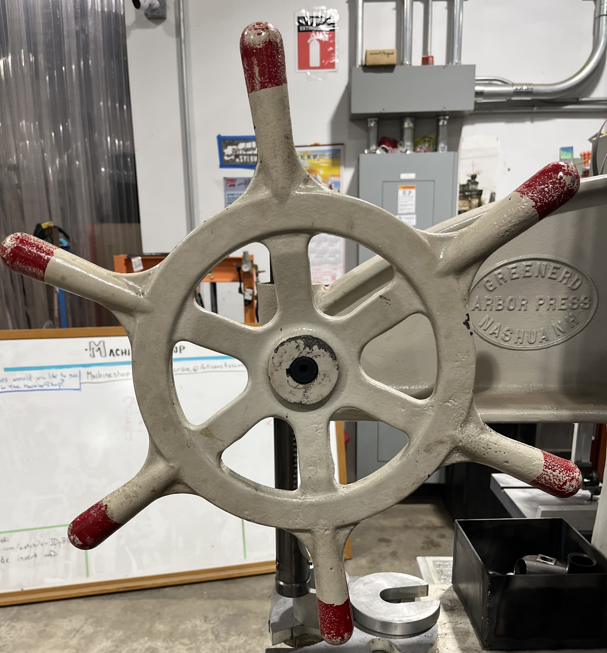
⚠️ The ships (AKA pilot) wheel is cast iron and attempting to apply more force using a wrench, "cheater" bar, or pipe on any of the handles or spokes will likely break the wheel. ⚠️
The Greenerd 3B arbor press with its deep throat design provides a much deeper reach than the regular version. The press is equipped with the smaller ships wheel, reducing its 3 ton capacity to 1.5 tons.
Hitting the top of the ram with a hammer or similar tool is not allowed because it damages the top.
If you need more force, use one of the other presses in the shop.

